Youtube Content Monetization Modeler – Miniproject 3

Project report
Jessica Sriramula

Introduction:
As video creators and media companies increasingly rely on platforms like YouTube for income, predicting potential ad revenue becomes essential for business planning and content strategy. My task is to build a Regression ML model after experimenting five different types of regression models and deciding based on accuracy the best ML model that can accurately estimate YouTube video ad revenue for individual videos based on various performance and contextual features, and implement the results in a simple streamlit web application.

Analysis:
For this project, I have written the python code for all the steps of the data analysis, visualisation and model analysis. Firstly, I have analysed the youtube ad revenue csv dataset file provided, by importing and reading the file in VScode, and utilised the pandas library. Then I have performed the different EDA steps such as null values treatment, outlier detection, feature engineering(adding more features that are necessary to the data), utilised the one hot encoding method to convert the categorical values of the columns into numerical values so that ML models can understand category, device and country columns, also checked and removed duplicate values in the dataset, also checked for any relationships in the dataset and trends in the dataset which contribute to the overall youtube ad revenue and found out that watch time in minutes contributes linearly to the overall youtube ad revenue whereas the other columns in the dataset do not contribute in a positive manner to the overall youtube ad revenue from the heat map. I have removed unwanted columns such as video_id and date columns that do not contribute to the ad revenue. I have also utilised matplot lib, seaborn and numpy in this data analysis for data analysis and visualisation.
After this part, I have used five different ML models which are linear regression, random forest, ridge regression model, lasso regression model and gradient boosting regression models to train and test the dataset variables(X,y) and then calculated the accuracy metrics R2score, MAE and RMSE for each of the models and compared the accuracy metrics of each model, because the R2 score value of the gradient boosting model is 95.05% compared to the other models which is 94.68% and 67.09% the best model to use is the gradient boosting model for estimating the youtube ad revenue overall, therefore I have implemented the gradient boosting model into my streamlit application to predict and estimate the overall youtube video ad revenue based on total number of likes, comments, views, subscribers, country, device and category. Below is the findings, insights and interpretation of my streamlit app gradient boosting model.

Findings, insights and interpretation of streamlit app model.
- From the streamlit application, if the total views is 1000 and all the remaining parameters are zero for an education, music, tech, lifestyle, gaming, entertainment ad video, then the estimated the total revenue is $241.41 if watching from a desktop or mobile or tablet or TV in all the countries UK,US,IN,CA,DE,AU as you can see in screenshot1 below. And if the total views is increased to 2000, 3000 and so on and keeping all the remaining parameters as zero then the total revenue is still $241.41 in all the countries for every device type and there is no effect, however increasing to19000 views gives $254.89 for all device types, video types and country, this means that as total views increases then the estimated ad revenue also increases, therefore total views contribute to ad revenue.
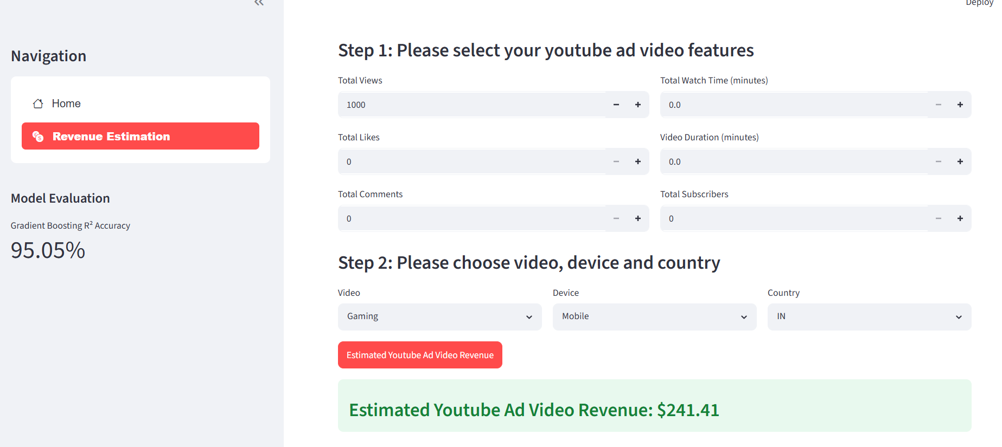
Screenshot 1.
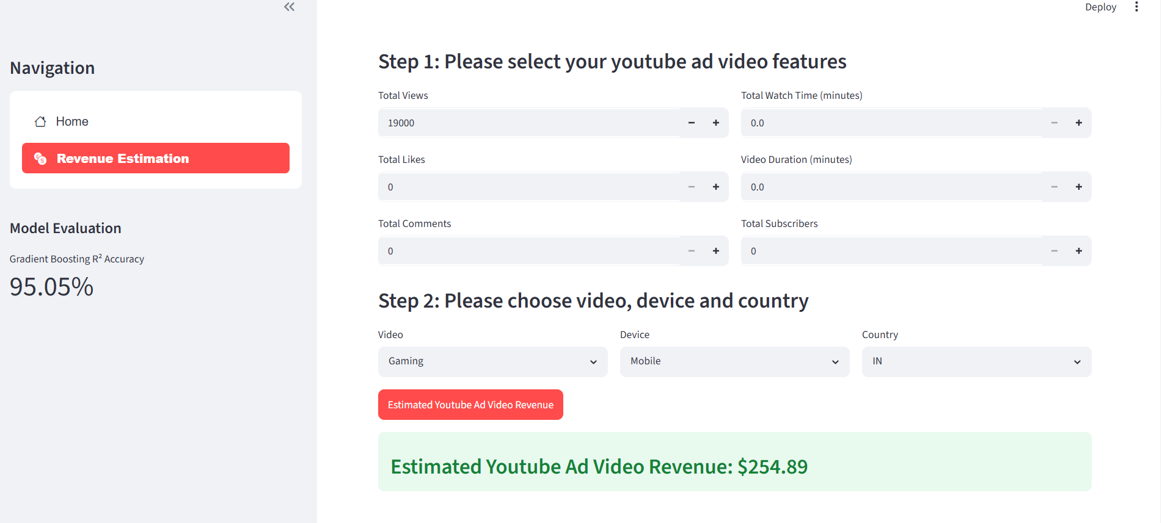
Screenshot1.

- But if total views are 6000 and likes are only 100, then the total ad revenue is decreased to $238.71 for all video and device types and countries but if likes is increased to 300 then ad revenue increases slightly to $242.02 and then to $242.78 for 400 likes in all the countries for all the device types. So as the number of likes increases the total ad revenue also increases slightly, therefore the total likes contributes to ad revenue as you can see in screenshot 2.
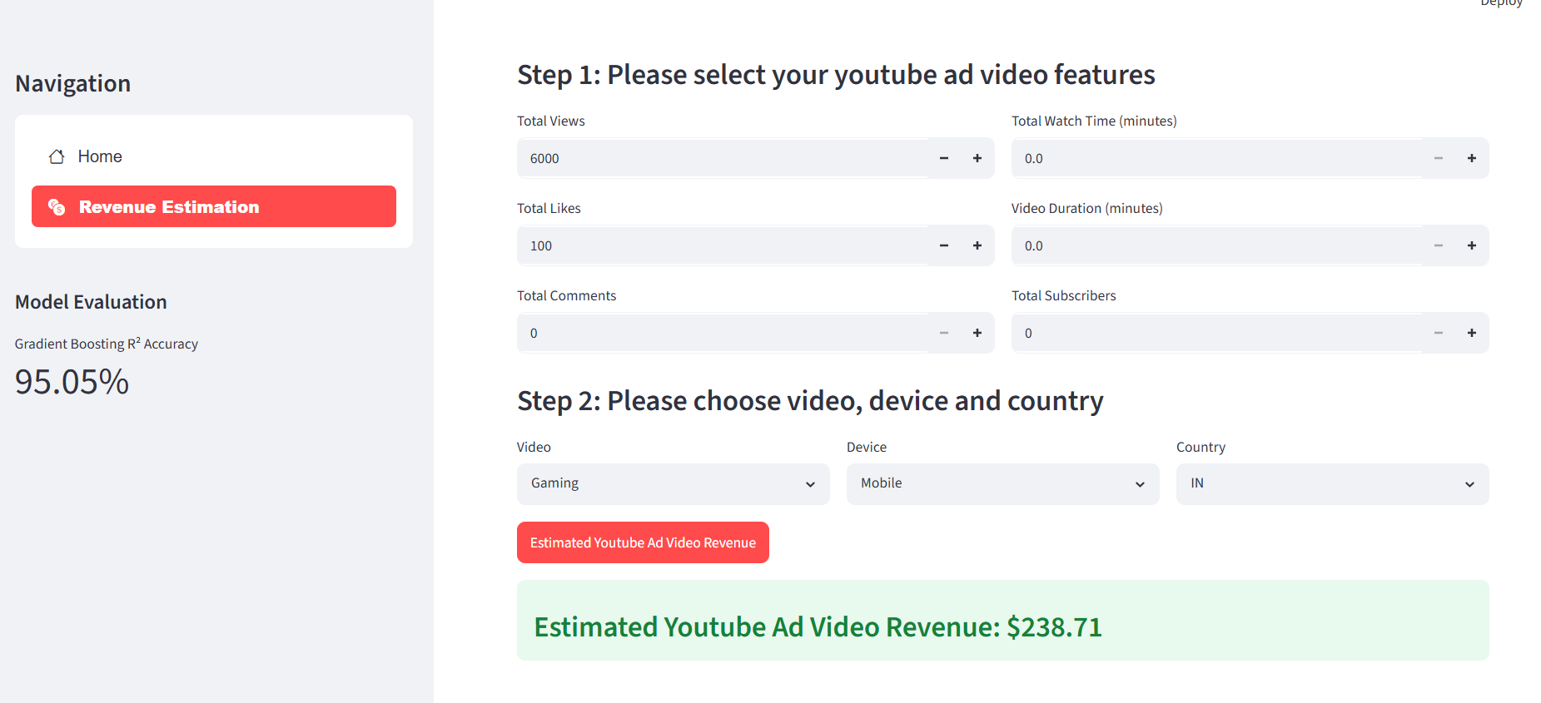
Screenshot 2.

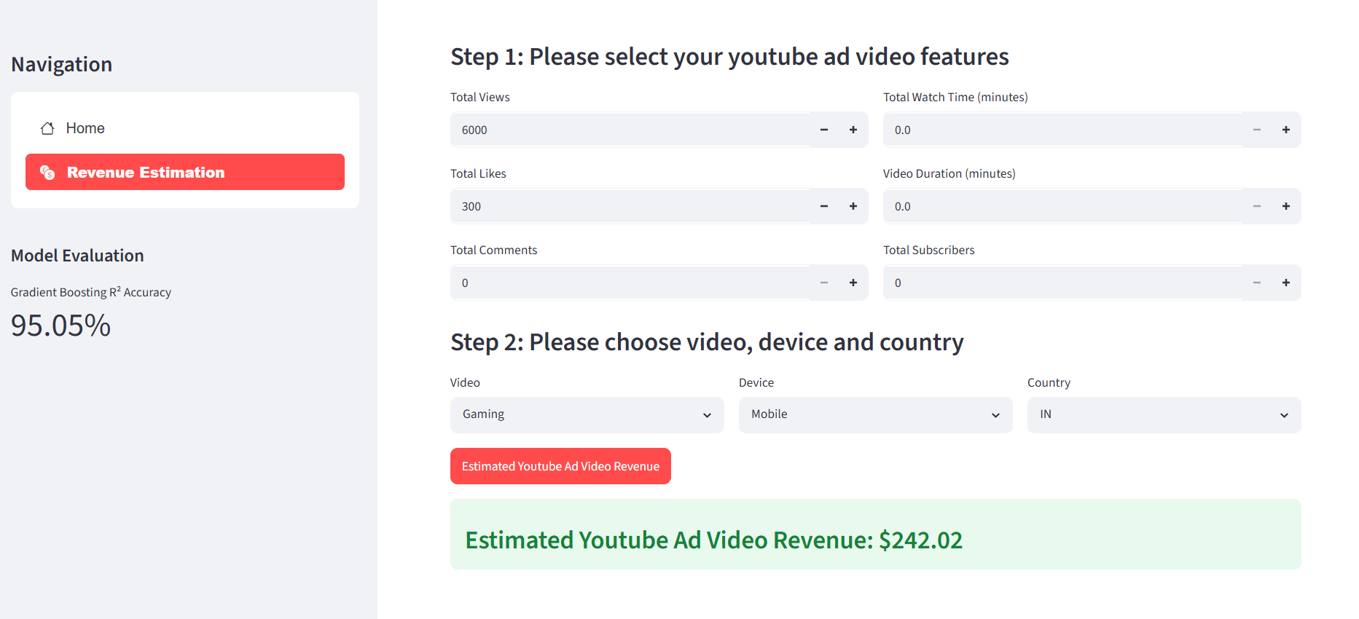
Screenshot 2.

- If the total comments is 10 and total views is 6000 and total likes is 40, then the estimated ad revenue is $235.92 for all device types and all video types in all the countries, keeping everything the same and if the total comments is increased to 20 then the estimated ad revenue stays the same for all the video types, device types in all the countries and if we keep increasing the total comments to 30 then the ad revenue decreases slightly to $234.32 and as we keep increasing the total comments to 50 the ad revenue also increases slightly to $241.40 and eventually to $242.36 for a total comments of 200 in all the countries and for each video type and device, this tells us that as the total number of comments increases the total ad revenue increases and decreases based on the total number of comments, therefore total comments contribute to ad revenue as you can see in screenshot 3.

Screenshot 3.
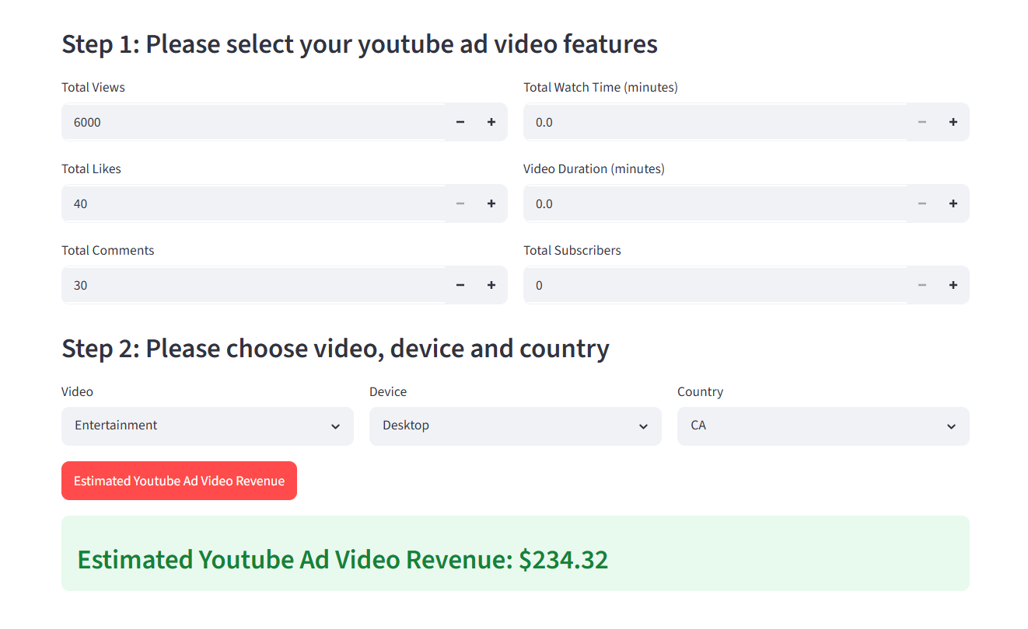
Screenshot 3.


Screenshot 3.


Screenshot 3.

- If the total views is 6000, total comments is 30 and total likes is 40 but if we increase the total watch time in minutes, from 500minutes to 5000minutes then the estimated total ad revenue decreases from $234.32 to $188.32 which is a decrease of $46 in all the countries for each video type and device. This means that if we increase the total watch time in minutes then the total estimated youtube ad revenue decreases, therefore total watch time contributes to the ad revenue as seen here in screenshot 4 below.

Screenshot 4.

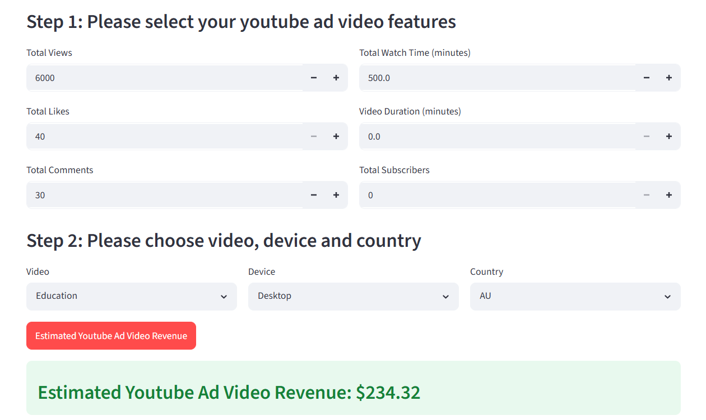
Screenshot 4.

- If we keep the total views as 6000 and total likes as 40 and total comments as 30 and total watch time as 500 and increase the total duration of the ad video from 1minute to 24 minutes then the estimated total ad revenue is $234.32 increased to $234.60 which is a small increase for all the video types, device and country and if we further increase the total duration of the video to 30 minutes then the ad revenue decreases to $227.78 and further increasing the video duration does not affect the ad revenue and the ad revenue still stays at $224.87 for all the device types, video in all the countries. This means that as the video duration increases and decreases, the estimated ad revenue also increases and decreases based on the video duration value, therefore video duration also contributes to the ad revenue.
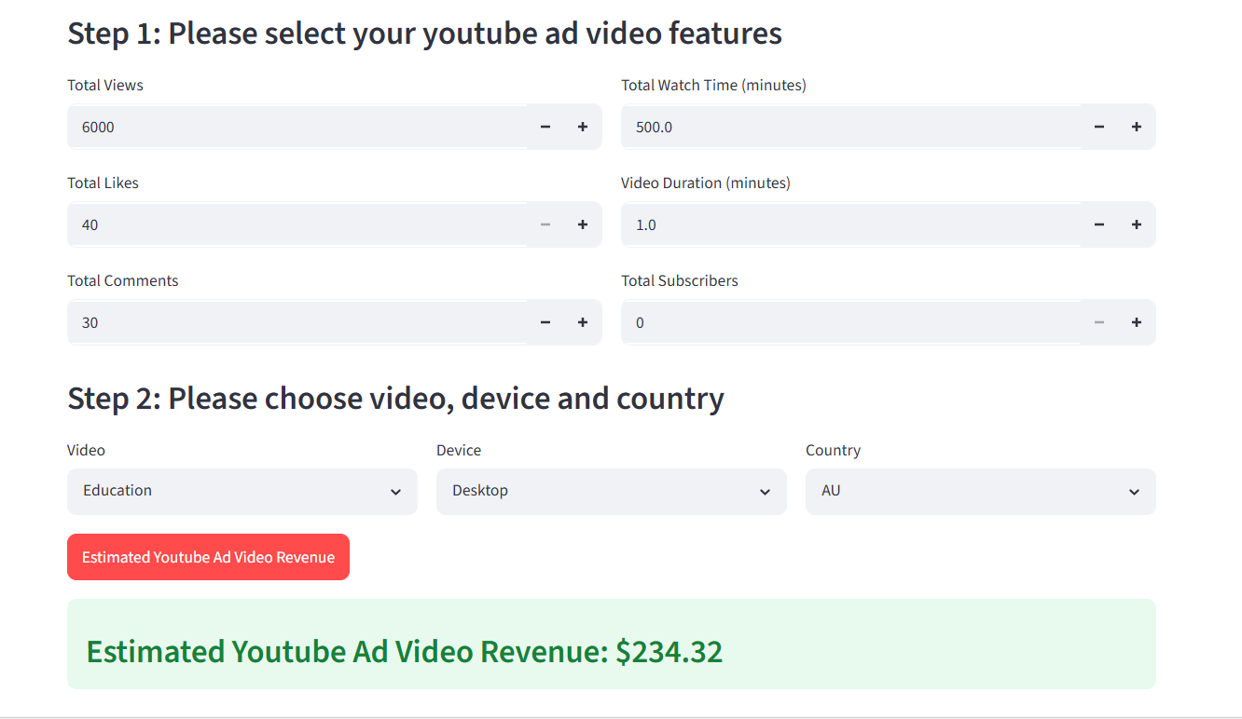
Screenshot 5.

Screenshot 5.


Screenshot 5.

Screenshot 5.

- If total views is 6000, total comments is 30 and total likes is 40 and total watch time is 500 minutes and video duration is 1.0 minutes and total subscribers is 50 then the total estimated youtube ad revenue is $234.32 for every video type, device and country. When we keep everything else the same but increase the number of subscribers from 50 to 500 then the estimated ad revenue still stays the same at $234.32 and if we further increase the subscribers to 900 the total ad revenue does not change. This tells us that increasing or decreasing the total subscribers does not affect the estimated ad revenue in any way. Therefore, total subscribers does not contribute to the ad revenue.

Screenshot 6.


Screenshot 6.

